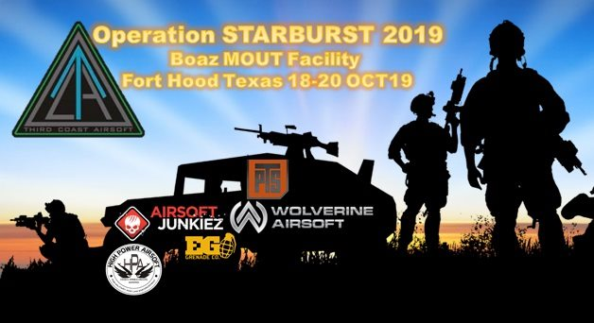Note to Players: Third Coast Airsoft, Airsoft Junkiez, and Event Sponsors want to thank you for attending OPERATION STARBURST 2019. The MOUT Sites of Boaz along with the terrain in between will be challenging, please take the time to drink water in the week leading up to the event. The following rules are common sense and 95% will follow the rules, but there is always that minority that will not.

GENERAL RULES

The following rules are universal to all TCA events and venues. These are the basics that every player should know without being told but need to be spelled out.
- ​Water container, full seal eye pro with retention strap, emergency reference card & if required, an Epi Pen.
- YOU MUST ATTEND THE SAFETY BRIEFING.
- Don’t try to “game” the event, enjoy the experience.
- Third Coast events are alcohol and drug free!
- Plastic, BIO BBS only.
- ALL PLAYERS MUST HAVE A RED LIGHT AND RED DEAD RAG.
- FPS limits for this event are hard and non-negotiable, ZERO EXEMPTIONS.
- Midcap magazines only.
  - Unless running a support weapon
- An individual can carry as many midcaps as they choose, you can reload anywhere on the field.
- All hits to the operator's body count as a kill, including web gear.
- Gun hits do not count, so long as it is the weapon in the hands of the shooter.
- Absolutely no shooting at anyone within the safe minimum engagement distance (MED) established for your weapon.
- If any operators have any disputes, they are expected to resolve them in a gentleman-like manner.
- We do not yell out for others to call their hits, the correct response is “check” or “ref check” TO CALL SOMEONE OUT RESULTS IN POINT DEDUCTION FOR YOUR SIDE.
- Indoors all weapons except SMG CLASS must be on semi (indoor to indoor shots in the same building).
- Electronic Warfare (ie jamming, listening in) IS NOT ALLOWED.
- Reloading magazines may be done anywhere on the field, so keep bags/speed loaders handy.
- Penalties for players not acting in accordance with the ruleset will cost their side objective points.
- Frequent violators will be told to leave, with photo being posted on social media.
- Friendly Fire counts.
- No blind firing. You must be able to see down the barrel of your weapon.
- Bang Bang Rule: No “Bang! Bang!” No surrender. No safety kills. A BB strike is the only thing that will take an opponent out.
- Ricochets do not count. However, rounds that snap vegetation and continue on to hit you do.
- While in the staging area pistols must be holstered. All other weapons must have the magazine removed and the chamber cleared.
- No dry or live firing in the staging area. If you need to test your weapon – proceed to the chrono station.
- While on the field/AO – eye protection must be on at all times. There are no safe zones or times. The AO is hot 24/7.
- Objectives captured must be dropped in place if the transporter (individual or vehicle) is hit. Whoever picks it up next controls it. Points are only awarded for objectives delivered to the TOC. However, once at a TOC, an objective cannot be recaptured (even if the TOC is overrun).
- Safety Call: “Blind Man” is the recognized call to make if you or another player is in distress and is unable to exit the field safely. Some examples of an appropriate use of the “Blind Man” signal:
  - Broken eye protection that leaves a player exposed.
  - A medical emergency requiring an ambulance.
  - “Blind Man” should not be used for a situation requiring staff transportation from the field. We can handle that situation without suspending gameplay.
- Physical Contact: Zero physical contact. No rubber knife kills are allowed at TCA events. No physical searches can be performed. At no point should you touch a local, admin or enemy except to help them up.
  - Enemy Search Procedures:
    - Get within 1 foot of person of interest.
    - Declare “You are being searched” to the target.
    - Searched individuals must hand over any game intel (kill cards, FRAGO elements, etc….).
- Accidents happen. It is a fast, competitive environment. If you do commit a transgression – be the bigger person: call yourself out, apologize to the victim of your transgression and take the walk to your respawn. Remember – it isn’t the mistakes we make… it’s how we make them right that sticks with people.

Task Organization

Each Faction is made up of 1-4 Company sized elements of 50-75 shooters.

Company
- Lead by a Company Commander
- Breaks into 2-3 Platoons

Platoon
- Lead by a Platoon Leader
- Breaks into 2-3 Squads

Squad
- Lead by a Squad Leader
- Includes approximately 8 shooters
- 1 Support Gunner
- 1 DMR or Sniper

Specialized Platoon/Squad
- Reports directly to the Force Commander
- Lead by 1 leader (regardless of force size)
- No restrictions on weapons

Only one specialized role per individual. Performing the one role is critical for the success of your mission.

1) Situation

Western Coalition Forces are preparing to launch an invasion of the KFORCE home islands. Eastern Imperial Forces supporting their KFORCE allies are preparing to conduct a defense and follow up counterattack in order to defend their homeland.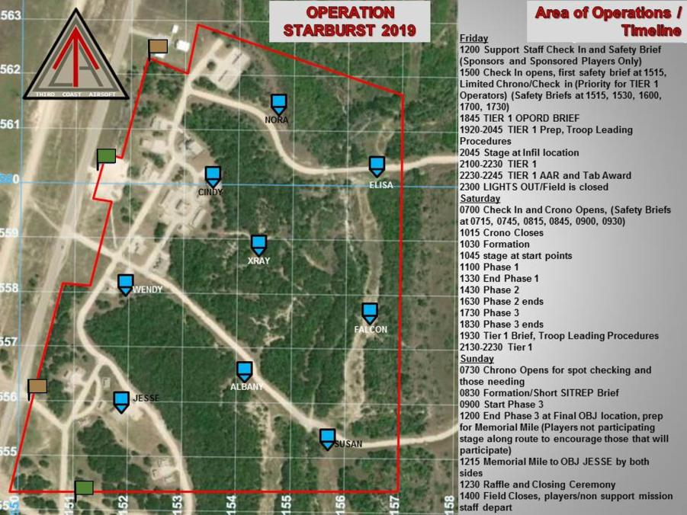

ZMonster is in paradise.

UNIFORMS
Uniforms identify different forces and provide a better experience.

Event specific. Refer to event page for approved uniforms.

You must attend and remain in the proper uniform for your side.

Uniform tops, bottoms and headgear must match the base color of your side.
- Allies/Western Forces (Tan based, Desert MARPAT, DCU, ACU, Multicam, desert tiger, 3 color desert)
- Task Force Darby: ACUs only, tan headgear is acceptable
- SOF: Desert DPM/Desert Tiger/3 Color Desert
- Tan headgear is acceptable no green/black/grey

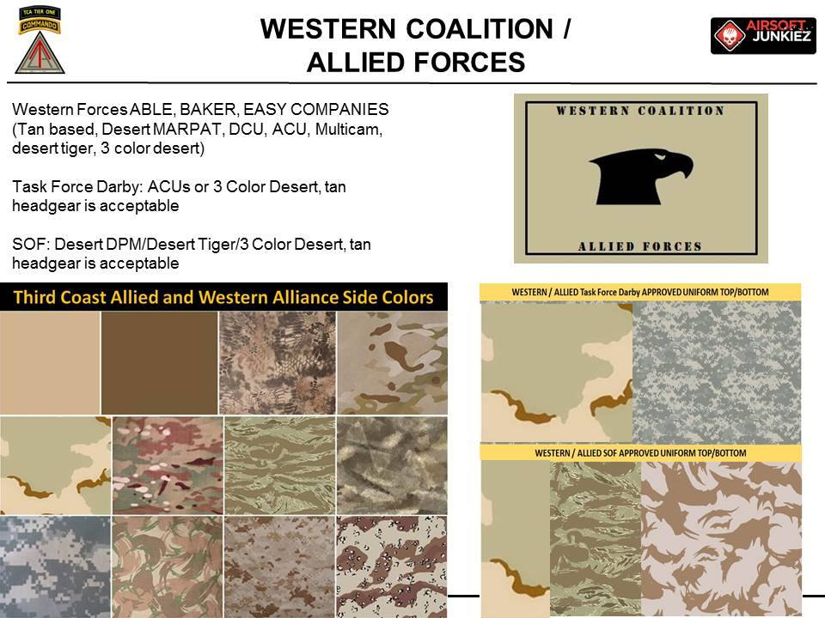

- KFORCES/Eastern Empire (Green based, Woodland, Woodland Marpat, CADPAT, Jungle Tiger, ATACs FG)
- KFORCE Airborne Regiment: Woodland Marpat, MC Tropic or British DPM, green headgear is acceptable
- KFORCE Commando: Russian Green Flora / British DPM / German Flecktarn
- Green headgear is acceptable no green/black/grey

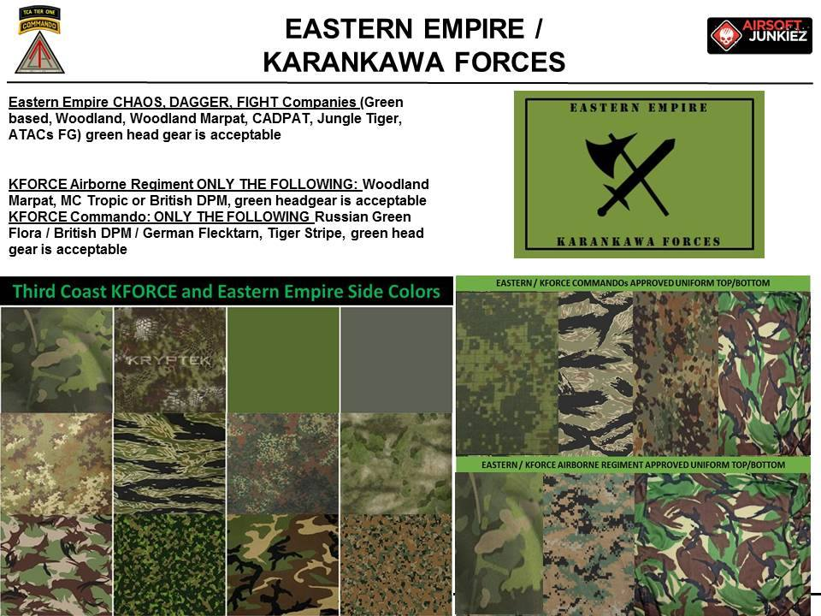

- The shirts and pants do not have to be the same pattern.
- Cold/wet weather clothing must also be the same base color of your side.
- Shirts are not optional for uniform tops, bottoms must be pants.
- Headgear will be side color specific. Camouflage or Solid colors authorized. NO BLACK HEADGEAR.
- Gear color does not matter.
- Black, gray or blue uniforms are for staff only.

A note about uniforms: Milsim airsoft is about team play and teamwork. Asking for an exception to the uniform requirements or showing up in a uniform no one else is wearing immediately tells everyone you are not a team player. However, if you and your squad want to show up in a bizarre glamoflage (that has the same base color as your side) you are certainly welcome. But make sure everyone in your squad is on the same page.

PHOTOGRAPHERS

TCA recognizes that we all like to look at the photos of the events. We all hope someone caught us doing something cool. But photographers cannot take away from the game itself and damage, in any way, the fabric of the game. Photographers are allowed on the field but must be registered for the event and in proper uniform.

Registration:
- Photographers must pre-register for events.
- There is a fee.
- No walk-on or pay-at-the-door photographers.
- Photographers must complete the Onsite Registration and attend a Safety Briefing.
- Photographers must have on proper eye protection at all times.

Photographers come in three varieties.
- Combat Journalist:
  - Perfect for a team photographer.
  - Must be in a uniform matching one side of the other – tan or green base.
  - Must stay with their faction.
  - PRESS patches on plate carriers is recommended but not required.
  - Medic rules apply if shot.
    - Must have a dead rag.
    - Must have 2 bandages.
    - Must return to a respawn for rest.
- UN Photographer:
  - Perfect for a professional photographer.
  - Must be is proper uniform.
    - Blue helmet (UN markings are encouraged but not required).
    - Plate carrier.
    - PRESS patches on front and back are required.
    - Light blue or white shirt (no red).
    - Blue or black pants (jeans are acceptable).
  - Can wander the field at will.
  - No medic rules.
    - UN Photographers should be considered civilians and should not be shot.
    - Factions can be accessed penalty points for shooting a UN Photographer.
  - UN Photographers have the most access throughout the field. No half-assing the uniform. Any piece missing will not be allowed on the field.
- Staff/Vendor Photographer:
  - Must have proper eye protection.
  - No permanent dead rags, safety vests or brightly colored clothing.
  - Vendor shirts are allowed.
  - Black, grey or blue pants.

No permanent dead rags. No safety vests. No brightly colored clothing. Anyone uncomfortable being shot will a plastic BB has no place on the field.

2) Mission:
Beginning 19 October 2019, Combined Ground Forces will attack to seize/defend the vital terrain objectives and execute on call time sensitive missions in order to deny enemy military units access to the Boaz Valley.

3) Execution
Intent: Forces seize and defend OBJs in order to defeat the Enemy through coordinated actions, making use of the platoons and squads to mass on the enemy and our objectives, while remaining flexible to react to TST missions in order to conduct raids to deny enemy of critical assets. Our forces will need to activate the Key Terrain beacons, seize occupation points and defend them in the event of a UN imposed ceasefire, those beacons and panels will credit sides with territory along with enemy nodes destroyed and ours defended.

Force and Company Commanders will coordinate amongst themselves to determine the best strategy to achieve the overall victory. Crucial to this is the maintenance of OBJECTIVE FOCUS.

OBJECTIVE FOCUS
Force and Company Commanders will coordinate amongst themselves to determine the best strategy to achieve the overall victory. Crucial to this is the maintenance of OBJECTIVE FOCUS.
- Platoons down to the individual rifleman must know the victory conditions necessary for winning. Before the start of each Evolution, orders are communicated to each side.
- Force commanders will direct troops at either Platoon or Squad strength to achieve objectives.
- Objectives, once met will result in victory points.
- Victory points will total over the course of the event determining the winner.
- This isn’t death match; no one will care how many of the enemy a rifleman has taken out if it achieves nothing in the way of victory points.

Fat Cobra likes Sour Patch Kids.

VICTORY CONDITIONS
TCA uses a combination of Battlefield Nodes, Digital Control Points, occupation OBJs and FRAGOS to determine the winning side at each event. Before the event, commanders will be given options for placement of their respective TOC, Mortar(s), and CCP(s). At the beginning of the game, each side will be responsible for setting up their various Battlefield Nodes. Staff will establish the Digital Control Points.
Establishing Battlefield Nodes:
AA (Alpha Alpha):
- Starting point.
- Permanent respawn location.
- Cannot be fired from.
- Cannot be fired into.
- Cannot be captured.
- Has no value to the enemy.
TOC (Tactical Operations Command):
- Command Post.
- At the beginning of the game – each side will be given a TOC kit containing a laptop and a flag (black and faction color with a block). You must get the bag (by foot or by transport) to your side’s chosen TOC location (tent or building adjacent to the tent), display the flag and place the laptop.
- Once active – command has access to air assets.
- Can be captured.
  - If captured – you lose air assets for the remainder of the round.
  - Flag will be returned at the end of the round.
- Can be moved between rounds.
  - Requires a reset – just like at the beginning of the game.
- Failure to establish the TOC results in 5000 points for that side.
Exploiting Battlefield Nodes:
TOC (Tactical Operations Command):
- Designated by a flag with the opposing team’s color in a square block.
- Capturing the TOC flag and returning it to your TOC disables air assets for the remainder of the round.
- Capturing the TOC flag and returning it to your TOC results in 5000 Victory Points.
- Individuals or vehicles transporting the flag, if hit, must drop the flag where they are hit.
CPP (Casualty Collection Point):
- NOT a capturable point.
- Removing the CCP flag will result in a point deduction for your side.
Digital Control Points:
Key points on the battlefield will be designated by a digital control tablet.
If you find a Digital Control Point:
- Access the tablet.
- In the bottom corners of the screen are colored buttons (bottom left is Western/bottom right is Eastern).
- Touch the appropriate color button, enter numeral code for your faction (1111 for Western/2222 for Eastern) take note of pop up message and report to your command, press the DISMISS button, close the access.
- DO NOT MOVE THE TABLET. Again. DO NOT MOVE THE DIGITAL CONTROL POINT.
Boxes may change sides several times during the battle.
Each second is a Victory Point for your side.
Report any malfunctioning digital control points to an admin immediately.
Moving a digital control point will result in a point deduction for your faction.
Occupation OBJ:
Key points on the battlefield will be designated on the map.
- If you find an occupation OBJ, you will display the provided color panel on the OBJ, the side showing at the end of the round, determines the point value for that side.
- Do not remove the panel or move the props at these OBJs.
FRAGOS:
Admins will assign missions to Commanders, Platoon Leaders or Squad Leaders in influence the flow of the battle.
- Points will vary.
- The first FRAGO will likely be the transportation of a water supply to your CCP.
Penalty Points:
Just as Victory Points can be awarded, they can be taken away for rules violations. The seriousness of the infraction, number of people involved and frequency call all impact the penalty.
Examples of things that will get you dinged:
- Arguing with an admin (will get you every time).
- Any direct rules violation.
- Bad sportsmanship.
- Improper eye protection.
- Improperly tagged weapon.
- Showing up late to chrono.

REGISTRATION PROCESS

All participants are required to pre-register for events. Registration information can be found on the individual event page. Our goal is to get you there. We can accommodate most payment options (message an Admin) but we do not allow players to pay-at-the-door.
- We do not offer refunds. The only refunds are for military (message an Admin).
- We do allow ticket transfers but these are the responsibility of the players (both seller and buyer of the ticket). You must notify TCA event staff of the name change. No scalping tickets. Sell it for what you paid.
- Participants are required to select a weapon class at registration. Do not purchase a rifleman ticket and show up with a sniper rifle. Sniper, support weapon and SMG slots are limited for a reason. However, snipers, support gunners and SMGs can run a standard rifle as a backup weapon.

On-Site:
- Registration/Check In: Upon arrival at the event – proceed to registration first. There you will receive your wrist band showing your specific weapon class and be issued your Emergency Contact Card.
- Safety Briefing: Next you will attend a Safety Briefing. This will give staff the opportunity to drill down AO specific objectives, obstacles, concerns and considerations. It is recommended you bring a small note pad to this for your own notes. At the completion of the Safety Briefing you will receive your event patch.
- Chrono: You will then proceed to the chrono station. The Jump Master will inspect your wrist band, patch, proper in game eye protection and verify you have everything needed to complete chrono. You will then proceed to the Beach Master to be assigned a chrono lane. Once you have successfully completed chrono your weapon and equipment will be tagged.
  - A limit of 4 weapons per player per trip to chrono.
    - You cannot chrono your buddy’s weapon (we do not have the opportunity to check their wrist band, patch and eye pro).
  - The chrono lane is not the place to tune your gun. If your gun needs work – step to the side to repair/adjust your weapon and then return TO THE END OF THE LINE.
  - If you lose or must remove either your wrist band or ANY of the items marking your weapon – it is your responsibility to contact an Admin for new tagging. Players found on the field without proper wrist band and/or weapon tagging will be escorted off the field immediately.
  - Complete chrono rules are below.
- You must complete all 3 of these steps to enter the game. Failure to complete all 3 steps is a direct violation and will be considered cheating and/or theft-of-services and be dealt with according to the Conduct guidelines.

The WARNORD and OPORD for each event will include a timeline for the opening and closing of each step of the On-Site Registration process. Showing up early or late (especially late!!!) will result in penalty points for your team and public shaming to your team.
- No exceptions.
- No excuses.
- Don’t be that guy.
- Everybody hates that guy.

CONDUCT

Airsoft is a game of honor and integrity. If you don’t have any – stay home. Your conduct on the field will make you famous or infamous – your choice.
- Bad Conduct: Players who steal, cause bodily harm or otherwise break the law will be referred to local law enforcement, ejected from the gam and banned from all future TCA events.
- Banned substances: TCA events are drug and alcohol free. This includes players, vendors and staff. Anyone in violation of the rule will be dealt with swiftly.
- Calling Hits: Do not call opposing team players’ hits. Calling opposing players out is poor sportsmanship and your side will be penalized.
- Chain of Command: Players should observe and respect ranks such as Squad Leader, Platoon Leader and Commanding Officer. Ranking officers will remember that airsoft is game and rank is tool to provide structure for everyone’s enjoyment.
- Cheating: CHEATING WILL NOT BE TOLERATED! You will be ejected from the event with no refund for repeat offenders. Penalties will be assessed for the entire side based on the individual’s actions.
- Feedback: We are an organization built by players for players. There is no such thing a negative feedback. Please – if you see something we can do better… tell us immediately. We are proud of the fact that 99% of our evolution has been player driven.
- Smack Talk: Airsoft is a competitive sport and some smack-talk is expected. But don’t call people names – especially people you don’t know. There will be no bullying, physical contact, obscenities (used in malice) or any form of physical or mental intimidation. This will get you sent home, banned and your information shared with other promoters.
- Rules: However you play at your home field, you will likely find it different here. Our rules are unique to TCA and in our experience offer a balance between a safe environment, a fair game design, a reasonable staff presence, enforceability and customer service. If you have a suggestion for a rules improvement – please bring it to a staff member and we will consider it for future events. But we will not change the rules of a game once it has started.

Drones

NO DRONES ALLOWED AT FORT HOOD, ACTIVE MILITARY AIRSPACE.

WEAPON CLASS AND CHRONO RULES
Chrono Procedure:
- Muzzle must be parallel to the opening of the chronograph.
- Hopup must be turned off. Leaving the hopup on may skew with chronograph readings.
- The player will fire 4 to 5 times through the chronograph. The highest reading is the one recorded on the chrono tag.
- For full auto weapons (SMGs and LMGs), we must chrono in both semi auto and full auto if applicable.
- Each weapon will have a chrono tag with the joule output written in permanent marker.
- If a player fails chrono, their name is recorded in the chrono-master book for future use/review.
HPA:
- Each HPA tank will have a pressure tag with the regulator pressure output written in permanent marker.
- All regulators will be zip tied and sealed with tamper tape (which we provide).

The weapon and your weapon class must match. You cannot stick a scope on an M4 and call it a sniper nor can you stick a box mag on a MP5 and call it a support weapon. TCA uses joules to chrono all weapons.

Rifle: Standard AEG or HPA replica weapon. Includes any service rifle replicas such as an M4, AR, AK, AUG, SCAR, HK416, Galil, L85, etc….
- 1.55 joules
- .32 gram BB – HPA/GAS and AEG
- 0ft MED
- Semi-auto only at all times
- Mid-cap only
SMG Class: A magazine fed, fully automatic replica carbine designed to fire pistol cartridges. Includes the MP40, M1A1, M3, Uzi, MP5, MAC 10, P90, MP7, etc….
- 1.00 joules
- .32 gram BB – HPA/GAS and AEG
- 0ft MED
- Full auto always allowed
- Mid-cap only
Pistol: Any standard semi-automatic or revolver replica used as a secondary side arm.
- All pistols must be chronoed.
- 1.55 joules
- .32 gram BB – HPA/GAS and AEG
- 0ft MED
Support Weapon: A replica weapon used to give infantry squads or sections a portable source of fully automatic firepower. Often select fire, fitted with a bipod. Includes the M60, Stoner, M27, RPK, L86, HK417, Minimi, etc….
- 1.86 joules
- .32 gram BB – HPA/GAS and AEG
- 50ft MED (REGARDLESS OF JOULES/FPS)
- Full auto allowed outdoors (must be select fire on semi to shoot indoors)
- Box or winding mags allowed, bipod required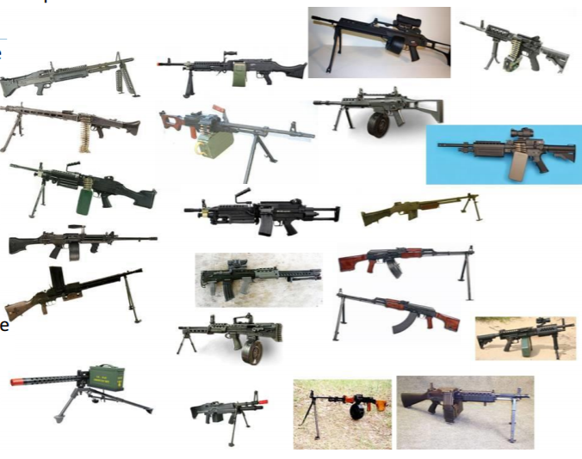
DMR: Unlike sniper rifles, DMRs are always semi-automatic replica rifles. Preferable to have a replica that holds a 7.62 sized magazine. Includes the HK417, SR-25, G3, M14 EBR, Mk 12 SPR, M16A4, SVD, etc….
- 2.1 joules
- .32 gram BB – HPA/GAS and AEG
- 75ft MED
- Semi-auto only
- Mid-cap only
- Must have a magnified optic and a bipod
Bolt Action Sniper: A long range, precision replica rifle with a bolt action, telescopic sight and a bipod. Includes the M40, M24, Barrett, CheyTac, etc….
- 3.6 joules
- .32 gram BB – HPA/GAS and AEG
- 100ft MED
- Semi-auto only
- Mid-cap only
- Must have a magnified optic and a bipod
Grenade Launcher: A replica weapon that fires a 40mm or similar rounds. Can either be a standalone weapon (either single-shot of repeating) or attaching to a parent replica. GP, M320, M203, M79, RG-6, MGL-140s and other commercially available grenade launchers to not require chrono. However, homemade launchers must be a faithful replica of an actual weapon and must be inspected by the chrono staff.
- 20ft MED
- Outdoor only
- Can fire BB, TAGGIN type rounds, or (nerf) rockets
- Refer to AO specific restrictions on the type of rounds allowed
Heavy Weapons: A replica mortar or anti-armor weapon used to incapacitate enemy vehicles. Must be a faithful replica of an actual weapon and must be inspected by the chrono staff.
- 20ft MED
- Outdoor only
- Can fire (nerf) rockets
- Refer to AO specific restrictions on the type of rounds allowed
Grenades: A small hand-thrown or launched replica expelling BBs (or peas) or detonating with a visible and/or audible charge. No homemade devices are allowed.
- 0ft MED
- Hand-thrown – indoor or outdoor
- Launched - outdoor only (can be fired from indoors to outdoors)
- Must be tossed (not thrown like a baseball)
- Refer to AO specific restrictions on the type of rounds allowed
- 10 ft kill radius (from where the grenade stopped moving)
  - This applies to TAG rounds as well. (MUST DETONATE)
- When thrown in a single Room all players in room are dead
- Do not load material into a device not designed to expel material (i.e.: BBs or glitter into a Thunder B is a dick move).
Smoke Grenades: Cold burning sport or marine grade smoke grenades of any color. No homemade devises are allowed.
- AO specific – refer to event page for restrictions beyond these rules
- Must be deployed outside only
  - If it rolls into a building – pull your dead rag, get it out of the building and return to your AA or CCP
- Do not throw directly at another player
- No smoke indoors
- Refer to AO specific restrictions on the type of rounds allowed

Indirect Fire: Staff managed simulated mortar rounds and airstrikes. May or may not include accompanying pyro/sound effects.
- Commanders will have limited amount of mortar/hellfire missile strikes/A10 gun runs that they can call in to disrupt enemy movement
- Simulated Mortar Strikes have a 10 ft kill radius
- Simulated Artillery Strikes have a 20 ft kill radius
- Simulated Airstrikes have a 50 ft kill radius
- NO PINK MIST unless ADMIN SAYS SO

Shields: No riot or ballistic shields are allowed.

Blank Fire Weapons: Player fielded blank fire weapons are not allowed (this does not include blank firing grenades). Only staff deployed blank fire weapons are allowed.

Rubber Knives: Rubber knives, rubber machetes and rubber tomahawks are allowed on gear for aesthetics only. They should not be brandished and have no effectiveness on the TCA battlefield. No rubber knife kills. And for God’s sake leave the lightsaber at home.

The beatings will continue until we hear the safe word.

VEHICLES

There are several factors leading to the evolution of vehicles used in airsoft: players getting more serious about their investment in airsoft, the increased availability of surplus military vehicles, the AO sizes getting larger and larger, etc…. It is important to remember that Milsim airsoft is a tribute to the infantryman. Vehicles should never dominate a game – they should only enhance it.

Ground Vehicles
- Must be a faithful representation of an actual military vehicle or technical (no Hobo-tanks).
- Must be approved by Senior TCA Staff prior to the event (include photos).
- 10mph limit on all roads, must be in first gear only.
- 5mph limit off-road (where allowed) and within 50 ft of players.
- Lights must be on for night/low-light maneuvers and brake lights must be operational.
- All drivers must be 18 years of age.
- Vehicles must have proof of liability insurance (PLUPs are acceptable but require proof) sent to staff along with vehicle photos for inspection.
- All vehicles must have a TC that will ground-guide the vehicle when backing up (even under fire) and supervise the loading and unloading of passengers (even under fire).
- All vehicles must have a fire extinguisher.
- All vehicles with a cab entry higher than 4 feet off the ground will require the vehicle driver and TC to wear hard head protection (a helmet) as they will enter and exit the vehicle without assistance.
- All vehicles must be equipped with a 2ft X 2 ft red flag on a pole or antenna to designate a hit.
- 3 violations and you are parked for the remainder of the event.
  - First strike – parked for 1 hour.
  - Second strike – parked for an evolution.
  - Third strike – parked for the weekend. Grab your rifle – you are walking.
- 2 types of vehicles are allowed:
  - Gun Trucks:
    - Typically a HUMVEE or modified Jeep, pickup or ATV (no station-wagons).
    - 1 mounted gun allowed (must stay mounted).
    - Vehicle must have a 3 man crew: Driver, TC and Gunner (exceptions made for photographers and staff).
    - Crew cannot dismount the vehicle to capture objectives.
    - Only the Gunner and TC can shoot.
      - Vehicle-Mounted Weapons: A replica weapon typically mounted on a vehicle to provide a portable source of fully automatic firepower. Includes the M240, MK 19, M2, M3, Minigun, M60, RPK, Minimi, etc….
        - 1.86 joules
        - .32 gram BB
        - 50ft MED
        - Full auto allowed
        - Box mags allowed
    - TC can fire his weapon from his station, no others may do so.
    - Must move in coordination with an infantry squad.
    - If hit, all occupants are dead. Vehicle and occupants must bleed out for 10 minutes and return to CCP/UMCP at the speed limit.
  - Transports:
    - Typically a Pinzguaer, LMTV, Deuce or 5-Ton (no mini-vans).
    - 1 mounted gun allowed.
    - Vehicle must have a 2 man crew: Driver and TC.
    - Crew and passengers can dismount the vehicle to capture objectives.
    - Passengers cannot fire from the vehicle.
    - If hit, all occupants are dead. Vehicle and occupants must bleed out for 5 minutes and return to CCP/ UMCP at the speed limit.
- Can be destroyed with a grenade detonating (it must detonate) within 10 ft of vehicle or a direct hit by a rocket. All troops outside the vehicle and within 10 ft, when hit are also dead (but can be medic-ed).
- Vehicles cannot move if troops are within 10 ft. This includes returning to CCP/UMCP.
- BBs cannot kill a vehicle nor its occupants (DO NOT FIRE BBS AT VEHICLES).
- Staff vehicles are used for game mechanics and cannot be killed.

STAFF

TCA’s core staff is made up of Active Duty and Retired Military Personnel. We also use auxiliary staff to support our efforts locally. We are all players first and love the game. We are fierce competitors and try our best to design the games we would want to play.
- OCs (Observer/Controllers) or Admins are the scenario referees.
- OCs call the shots, mediate issues, make judgement calls and provide general customer service.
- OCs are in grey or black uniforms to distinguish them from players.
- OCs have to make the rules fair for everyone. An exception for one person may mean others suffer.

Case-by-case is the very definition of discrimination. Unless you are prepared to defend why you are not held to the same standards as all other players – do not ask an OC for an exception.

TIER 1 MISSIONS

TCA offers a separate experience for those ready for a truly immersive MILSIM experience. Our Tier 1 missions challenge the mental focus, physical condition and character discipline of the most competitive Milsim shooters. Designed and executed by Active Duty and Retired Military Personnel, Law Enforcement, featuring intense mission development, pyrotechnics, coordinating vehicle support, a highly trained OPFOR and much more. Tier 1 Missions are generally offered on Friday and Saturday nights and do require a separate fee. See the event page for more details and timelines.

Friday
1200 Support Staff Check In and Safety Brief (Sponsors and Sponsored Players Only)
1500 Check In opens, first safety brief at 1515, Limited Chrono/Check in (Priority for TIER 1 Operators) (Safety Briefs at 1515, 1530, 1600, 1700, 1730)
1845 TIER 1 OPORD BRIEF
1920-2045 TIER 1 Prep, Troop Leading Procedures
2045 Stage at Infil location
2100-2230 TIER 1
2230-2245 TIER 1 AAR and Tab Award
2300 LIGHTS OUT/Field is closed

Saturday
0700 Check In and Chrono Opens, (Safety Briefs at 0715, 0745, 0815, 0845, 0900, 0930)
1015 Chrono Closes
1030 Formation
1045 stage at start points
1100 Phase 1
1330 End Phase 1
1430 Phase 2
1630 Phase 2 ends
1730 Phase 3
1830 Phase 3 ends
1930 Tier 1 Brief, Troop Leading Procedures
2130-2230 Tier 1

Sunday
0730 Chrono Opens for spot checking and those needing
0830 Formation/Short SITREP Brief
0900 Start Phase 4
1200 End Phase 4 at Final OBJ location, prep for Memorial Mile (Players not participating stage along route to encourage those that will participate)
1215 Memorial Mile to OBJ JESSE by both sides
1230 Raffle and Closing Ceremony
1400 Field Closes, players/nonsupport mission staff depart

4) Service and Support
SAFETY

Airsoft is a sport and, like any other sport, requires safety equipment.

Required safety equipment:
- Dead Rags: Red dead rags are required for daylight operations outdoors. Red lights are required for indoor or nighttime operations.
- Ear Protection: Although not required – it is recommended. You will be in tight spaces with plenty of pyro going off all around you. If you have sensitive hearing, are concerned about hearing loss or have a pre-existing hearing condition – ear plugs or sound dampening headphones are recommended.
- Emergency Contact Card: A 3X5 ECC (available at registration) must be on all players at all times. Your ECC should include:
  - Your Name
  - On the field contact (name and phone number)
  - Emergency contact (name and phone number)
  - Medical conditions and/or known allergies
- Eye Protection: All players must wear approved eye protection with a tight seal around the face and a retention strap with no gaps bigger than a pencil eraser.
  - Approved eye protection is:
    - ANZI rated lenses
    - Full seal
    - Includes a retention strap
  - No mesh eye protection is allowed.
  - Malfunctions happen. Return to the staging area immediately if your eye protection needs attention.
  - Players found without proper, approved eye protection will be ejected from the game. No excuses.
- Footwear: Closed toed shoes or boots are required and ankle supporting footwear is highly recommended.
- Full Face Protection: Players 17 years old and under must have full face protection. Players 18 and older are encouraged to wear full face protection but it is not required. A hard-solid full mask or a hard or mesh lower face shield in combination with full-seal goggles is acceptable. Fabric items such as shemaghs, balaclavas and bandanas are not acceptable lower face protection for players 17 and under.
- Hydration: All players are expected to provide their own water and are required to have a water source on them during the game. Staff will provide water in emergency situations (if staff is giving you water – you are being carted off the field). 5 Gallon water jugs will be supplied at CCPs and AAs.
- Real Weapons: Real steel weapons are not allowed at TCA events. This is nothing against our 2nd Amendment rights: The risk of confusion is too great. If you travel with a personal carry – please lock it away at your hotel or in your vehicle where it is absolutely inaccessible.

MEDIC RULES
In actual combat – a buddy getting hit is a chaotic period on the battlefield. TCA’s medic rules are designed to emulate some of that chaos while getting players back into the game in a reasonable timeframe.
- All participants must have 2 mock bandages on their person at all times. Approved bandages including ACE bandages (cut down to 2-3 ft), TCA Tourniquets or modified tourniquets suitable for airsoft use. No red bandages.
- Everyone is a medic.
- When you are hit you must die in-place, call out a loud “HIT” and display a RED DEAD RAG (or a RED LIGHT in dark areas/night).
- Act as if you have been shot (good acting can result in a “God Respawn” if an admin witnesses a worthy performance).
- Remain motionless. DO NOT STAND, you must sit or lay down.
- Call out for a Medic/Corpsman/Mommy.
- If a buddy/medic can get to you:
  - The medic can drag/walk you to cover
  - Present your bandage to the medic
  - The medic must attach/tie to bandage to your arm or leg
  - No self-medicating
  - Repeat for a second hit
  - Third hit – bleed out for 5 minutes, place your dead rag on your head, raise your rifle over your head and return to your AA or CCP
- If a medic cannot get to you:
  - Bleed out for 5 minutes, place your dead rag on your head, raise your rifle over your head and return to your AA or CCP
- Bleeding-out or dead men do not talk to live operators (not even about the weather).
- Bleeding-out or dead men do not talk on the radio, not even to say, "I'm dead."
- Ambulance rides (via team or staff transport) are allowed.

5) Command and Signal
Communications will be by UHF/FRS radio. The following Signals Operating Instructions are in effect:
STAFF:
FRS 1 462.5625
FRS 2 462.5875

WESTERN COALITION (Platoon/Squad assignments at commander’s discretion)
FRS 3 462.6125
FRS 4 462.6375
FRS 5 462.6625
FRS 6 462.6875
FRS 7 462.7125
FRS 8 467.5625
FRS 9 467.5875
FRS 10 467.6125
FRS 11 467.6375
FRS 12 467.6625
EASTERN EMPIRE (Platoon/Squad assignments at commander’s discretion)
​FRS 13 467.6875
FRS 14 467.7125
GMRS 15 462.5500
GMRS 16 462.5750
GMRS 17 462.6000
GMRS 18 462.6250
GMRS 19 462.6500
GMRS 20 462.6750
GMRS 21 462.7000
GMRS 22 462.7250

